Experiment 4

Student Name: Nikhil Kumar UID: 25MCI10036
Branch: MCA (AI/ML) Section/Group: 25MAM-1(A)
Semester: 2-SEM Date of Performance: 03/02/2026
Subject Name: Technical Training - 1 Subject Code: 25CAP-652

- Aim of the Session:

To understand and implement iterative control structures in PostgreSQL conceptually, including FOR loops, WHILE loops, and basic LOOP constructs, for repeated execution of database logic.

- Software Requirements:
- PostgreSQL
- pgAdmin
- Windows Operating System

- Objectives of the Session:
- To understand why iteration is required in database programming
- To learn the purpose and behaviour of FOR, WHILE, and LOOP constructs
- To understand how repeated data processing is handled in databases
- To relate loop concepts to real-world batch processing scenarios
- To strengthen conceptual knowledge of procedural SQL used in enterprise systems

- Theory:

In real-world database applications, tasks often need to be repeated multiple times. Examples include processing employee records, generating reports, validating data, applying salary increments, and running batch jobs. Standard SQL is declarative and works well for single operations, but repeated logic requires procedural control.

PostgreSQL provides PL/pgSQL, a procedural extension that supports iteration using loop structures. These loops allow SQL statements to execute repeatedly until a specific condition is met.

Iteration in PostgreSQL is commonly used inside:
- Stored procedures
- Functions
- Anonymous execution blocks

Large organizations such as Amazon, SAP, Oracle, and Rippling use loop-based logic for payroll processing, billing cycles, analytics, and automation workflows.

Types of loops in PostgreSQL

1. FOR Loop (Range-Based)
- Executes a fixed number of times
- Useful when the number of iterations is known in advance
- Commonly used for counters, testing, and batch execution

2. FOR Loop (Query-Based)
- Iterates over rows returned by a query
- Processes one row at a time
- Frequently used for reporting, audits, and row-wise calculations

3. WHILE Loop
- Executes repeatedly as long as a condition remains true
- Suitable for condition-controlled execution
- Often used in retry logic or threshold-based processing

4. LOOP with EXIT Condition
- Executes indefinitely until explicitly stopped
- Provides maximum control over execution flow
- Used in complex workflows where exit conditions are custom-defined

- Practical / Experiment Steps:

Example 1: FOR Loop – Simple Iteration
- The loop runs a fixed number of times
- Each iteration represents one execution cycle
- Useful for understanding basic loop behaviour

Application: Counters, repeated tasks, batch execution

Code

DO $$

DECLARE

i INT;

BEGIN

FOR i IN 1..5 LOOP

RAISE NOTICE 'Iteration number: %', i;

END LOOP;

END $$;

Output

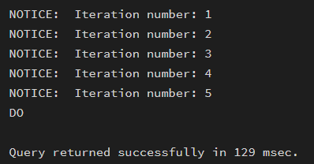

Example 2: FOR Loop with Query (Row-by-Row Processing)
- The loop processes database records one at a time
- Each iteration handles a single row
- Simulates cursor-based processing

Application: Employee reports, audits, data verification

Code

create table employees(

emp_id int,

emp_name text,

salary numeric(10,2)

);

INSERT INTO employees VALUES

(1, 'Amit', 42000),

(2, 'Neha', 55000),

(3, 'Rahul', 48000),

(4, 'Priya', 62000);

DO $$

DECLARE

rec RECORD;

BEGIN

FOR rec IN SELECT emp_id, emp_name FROM employees LOOP

RAISE NOTICE 'Employee ID: %, Name: %', rec.emp_id, rec.emp_name;

END LOOP;

END $$;

Output

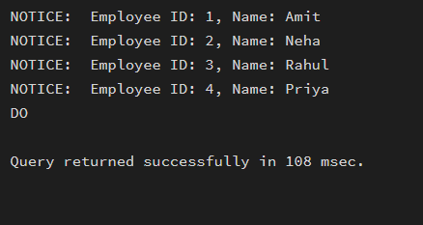

Example 3: WHILE Loop – Conditional Iteration
- The loop runs until a condition becomes false
- Execution depends entirely on the condition
- The condition is checked before every iteration

Application: Retry mechanisms, validation loops

Code

DO $$

DECLARE

counter INT := 1;

BEGIN

WHILE counter <= 5 LOOP

RAISE NOTICE 'Counter value: %', counter;

counter := counter + 1;

END LOOP;

END $$;

Output

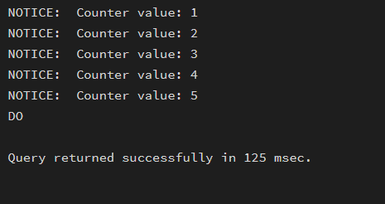

Example 4: LOOP with EXIT WHEN
- The loop does not stop automatically
- An explicit exit condition controls termination
- Gives flexibility in complex logic

Application: Workflow engines, complex decision cycles

Code

DO $$

DECLARE

x INT := 1;

BEGIN

LOOP

RAISE NOTICE 'Value: %', x;

x := x + 1;

EXIT WHEN x > 5;

END LOOP;

END $$;

Output

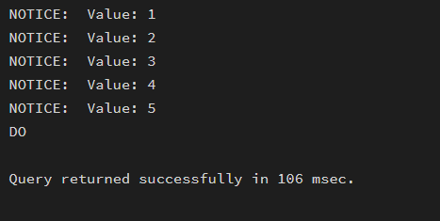

Example 5: Salary Increment Using FOR Loop
- Employee records are processed one by one
- Salary values are updated iteratively
- Represents real-world payroll processing

Application: Payroll systems, bulk updates

Code

DO $$

DECLARE

rec RECORD;

BEGIN

FOR rec IN SELECT emp_id FROM employees LOOP

UPDATE employees

SET salary = salary + 1000

WHERE emp_id = rec.emp_id;

END LOOP;

END $$;

SELECT * FROM employees;

Output

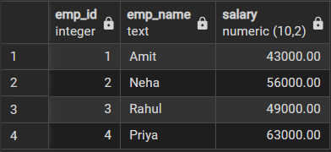

Example 6: Combining LOOP with IF Condition
- Loop processes each record
- Conditional logic classifies data during iteration
- Demonstrates decision-making inside loops

Application: Employee grading, alerts, categorization logic

Code

DO $$

DECLARE

rec RECORD;

BEGIN

FOR rec IN SELECT emp_name, salary FROM employees LOOP

IF rec.salary >= 50000 THEN

RAISE NOTICE '% is a High Salary Employee', rec.emp_name;

ELSE

RAISE NOTICE '% is a Low Salary Employee', rec.emp_name;

END IF;

END LOOP;

END $$;

Output

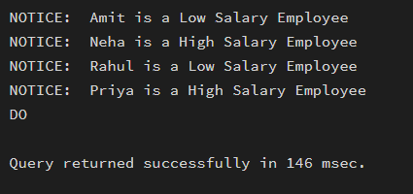

- Learning Outcomes (What I have learned):

This experiment helps students understand how iterative control structures work in PostgreSQL at a conceptual level. Students learn where and why loops are used in database systems and gain foundational knowledge required for writing procedural logic in enterprise-grade applications.

